“Sister” by Leona Gom

“Sister”

She is holding my hand

but I can’t remember it,

whether it was something automatic

like smiling for the camera

5 or whether our mother had to say

*take her hand, come on*.

Mostly we remember

who hit who first,

who was pushed off the sled,

10 who tattled to father,

all that stale history still

squashed between us 30 years later.

It becomes easier every year

to think it is too late,

15 we are too different now,

the letter at Christmas as much

as there will ever be.

But still I return to the old albums,

touch the glassy photographs

20 with their secrets sealed in.

My fingertips find the two small faces

I want to forgive, find

the sister holding my hand.

**PRACTICE QUESTIONS:**

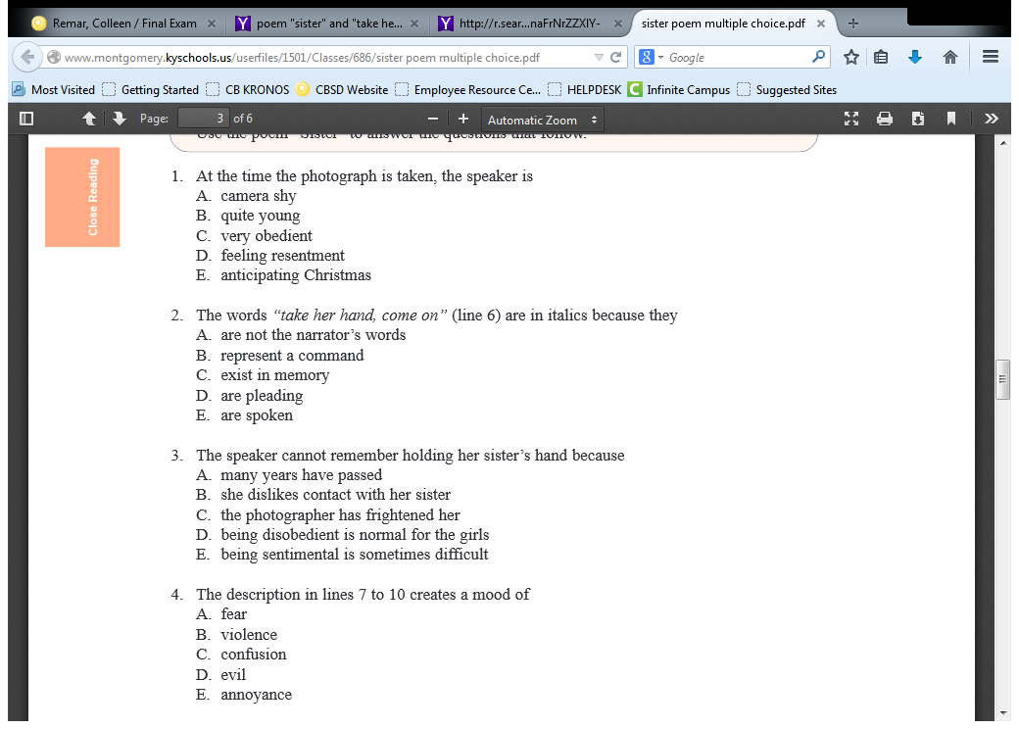

1. Love
2. Aggression
3. Indifference
4. Respect
5. Delight

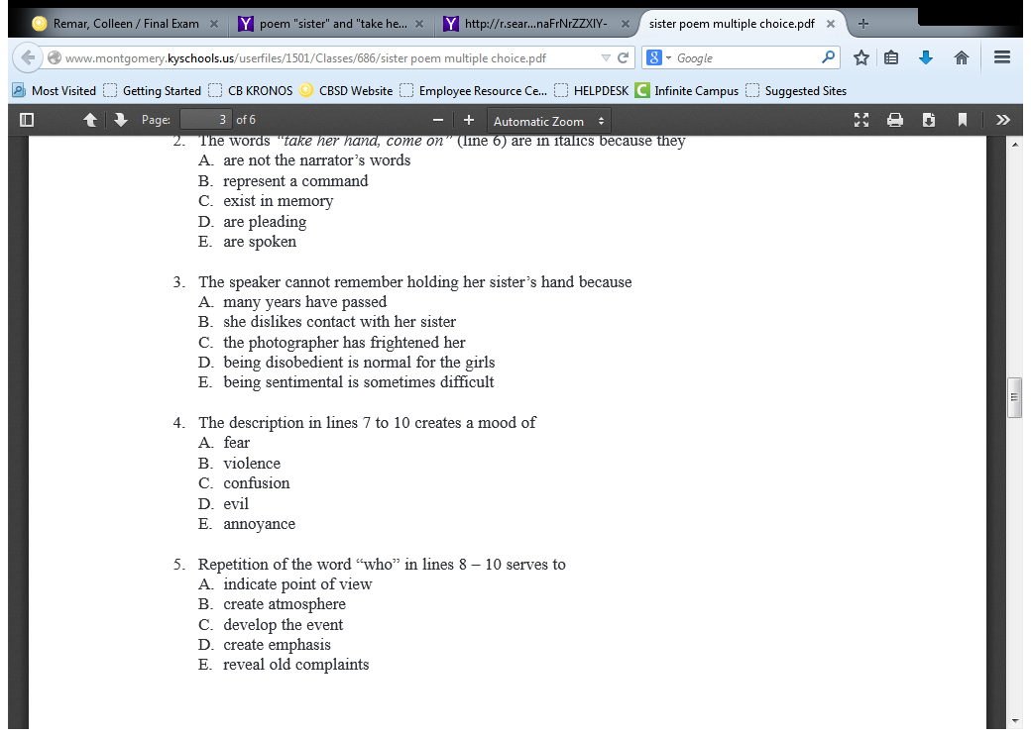

SKIP # 5 and 6

